***Received a grade of 100****

@charset "utf-8";

/*

New Perspectives on HTML5 and CSS3, 8th Edition

Tutorial 3

Case Problem 1

Layout styles for Slate and Pencil Tutoring

Author:

Date: 04/05/2023

Filename: sp_layout.css

/* Window and Body Styles */

html {

height: 100%;

}

body {

width: 95%;

min-width: 640px;

max-width: 960px;

margin-left: auto;

margin-right: auto;

min-height: 100%;

}

img {

display: block;

}

/* CSS Grid Styles */

body {

display: grid;

grid-template-columns: repeat(4, 1fr);

}

img#logo {

grid-column: span 3;

width: 100%;

}

nav.horizontal, footer {

grid-column: span 4;

}

aside {

grid-column: span 2;

}

/* Horizontal Navigation List Styles */

nav.horizontal li {

display: block;

width: 12.5%;

float: left;

}

/* Section Styles */

section img {

width: 50%;

margin: 0px auto;

}

section p {

width: 70%;

margin: 0px auto;

}

/* Customer Comment Styles */

aside {

width: 75%;

padding-bottom: 30px;

}

aside:nth-of-type(odd) {

justify-self: end;

}

aside img {

float: left;

width: 20%;

}

aside p {

float: left;

width: 75%;

margin: 5px;

}

--------------------------------------------------------------------------------------------------------------------------------------------

Summary

Slate & Pencil Tutoring - Karen Cooke manages the website for Slate & Pencil Tutoring, an online tutoring service for high school and college students. Karen is overseeing the redesign of the website and has hired you to work on the layout of the site’s home page. *Figure 3–84* shows a preview of the page you’ll create for Karen.

[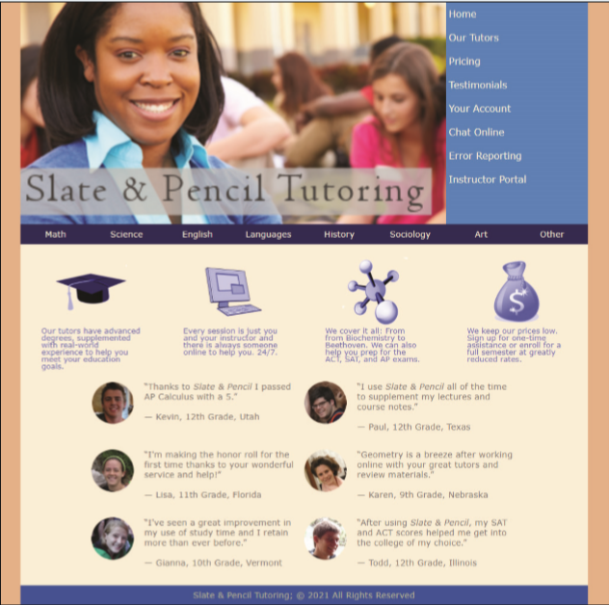](https://cdn.filestackcontent.com/D010jfNQS82p116MfMyH)*Figure 3-84*

Karen has supplied you with the HTML file and the graphic files. She has also given you a base style sheet to initiate your web design and a style sheet containing several typographic styles. Your job will be to write up a layout style sheet according to Karen’s specifications

## Document Setup

Open the sp_home.html and sp_layout.css files and enter your **name** and the **date** in the comment section of each file. Next, go to the sp_home.html file and within the document head, create links to the sp_base.css, sp_styles.css, and sp_layout.css style sheet files.

## Window and Body Styles

Open the sp_layout.css file. Go to the "Window and Body Styles" section. Create a style rule for the html element that sets the height of the browser window at **100%**. Create a style rule for the page body that sets the width to **95%** of the browser window ranging from **640** pixels up to **960** pixels. Horizontally center the page body within the browser window. Karen wants to ensure that the height of the page body is always at least as high as the browser window itself. Set the minimum height of the browser window to **100%**. Finally, add a style rule to display all inline images as blocks.

## CSS Grid Styles

Within the "CSS Grid Styles" section create a style rule that displays the body element as a grid with four columns of length **1fr**. Create a style rule for the img element with id logo so that the logo image spans three columns and has a width of **100%**. For the horizontal navigation list and the footer element create a style rule so that those elements span four columns. Create a style for the aside element to span two columns.

## Horizontal Navigation List Styles

Within the "Horizontal Navigation List Styles" section create a style rule for li elements nested within the horizontal navigation list that display each element as a block with a width of **12.5%** and floated on the left margin.

Section Styles

Within the "Section Styles" section create a style rule for inline images within the section element that sets the width of the image to 50% and centers the image using a top/bottom margin of 0 and a left/right margin of auto.

Create a style rule for paragraphs within the section element that sets the width of the paragraph to 70% and centers the paragraph using a top/bottom margin of 0 and a left/right margin of auto.

Customer Comment Styles

Go to the "Customer Comment Styles" section and create a style rule for the aside element setting the width to 75% and the bottom padding to 30 pixels. The six aside elements will be displayed in two columns. For odd-numbered aside elements, use the justify-self grid property to place the element on the end (right) margin.

Use the nth-of-type(odd) pseudo-class to select the odd-numbered aside elements.

Float inline images nested within the aside element on the left with a width of 20% and float paragraphs nested within the aside element on the left with a width of 75% and a left margin of 5%.

Task

When you have completed the assignment, check this task, open the task list and submit your work to your instructor.